SMART WATER MANAGEMENT

# A Project report submitted in partial fulfillment of the Requirements for the degree of B.E Computer Science and Engineering

By,

S.SARANYA(513221104023)

# Under the supervision of professor and HOD department of B.E Computer Science and Engineering

Phase-5:

Problem statement

Design thinking approach

# Phases of development Data processing Machine learning technique Innovative techniques

Problem statement:

Worldwide water scarcity is one of the major problems to deal with. Smart Cities also faces this challenging problem due to its ever-increasing population and limited sources of natural water. Additionally, careless usage of water and large water wastage has made the water issues as a serious concern. Today Smart Cities are using advanced technical...

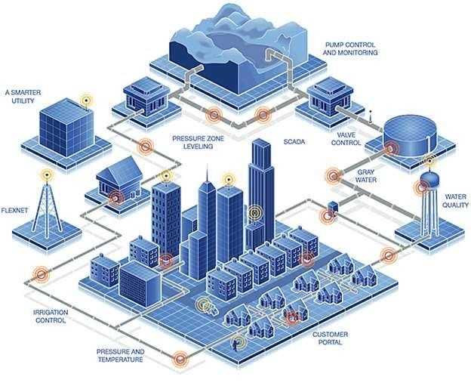

Design Thinking Approach:

This is where the problem arises. The pump is usually operated manually using a switch. The pump is turned on to fill the tank when the residents discover a thinning tap and this can happen without warning. There have been many instances of this happening in the middle of me taking a shower and it’s frustrating. An even bigger problem is when someone forgets to switch the pump off and water starts overflowing from the overhead tank. This was a regular occurrence in my neighborhood. The system was simply not designed to make the experience comfortable for its users. People were not given sufficient feedback about the situation and they had to suffer in the form of paying excess water bills or staring at empty taps when they really needed water.

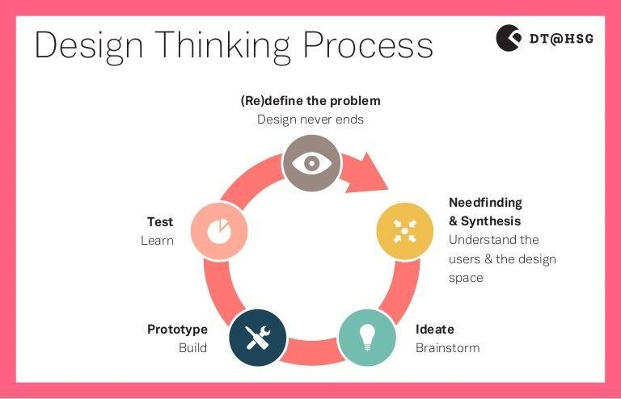

Phases of development:

This paper presents the design and implementation of a smart water management system using IoT technology. The system includes a wireless sensor network, a cloud platform, and a mobile application. The system allows real-time monitoring and control of water usage, and it provides users with personalized recommendations for water conservation.

The management of water resources is an essential aspect of sustainable development, and it is critical to the success of many industries, such as agriculture, energy, and urbanization. Due to the increasing demand for water resources, the need for efficient and smart water management systems is becoming more important. The Internet of Things (IoT) technology is a suitable solution to tackle the issue of water management. This proposed system aims to develop a smart water management system using IoT technology to address the water scarcity problem.

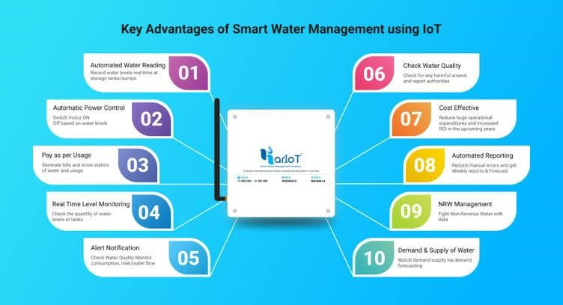

Data processing :

**The aim of our project was not to merely find ways to connect the process of pumping water to a mobile app, rather to explore ways to make the entire system smarter by leveraging technology.** While we couldn't address every single touch-point involved in the process, we addressed the 3 most important concerns raised by the people we spoke to -

1. Knowing current water level in the tanks without having to find an empty tap or running outside.
2. Knowing when the next government water supply is & other critical water related information.
3. Being able to turn the pump on/off remotely and when needed without worrying about the tank overflowing.

Machine learning technique:

The water saving technique with block chain includes incorporating block chain technology into environmental protection, including thorough transparency in mitigating knowledge asymmetry which promotes stronger market structures in resource allocation.

Block chain has always been an effective tool for such kind of contracts. It ensures heavy penalties against those who are not following desired rules required for water savings.

There is no central governor of the network,which means that consensus can be achieved without centralized control. The right and responsibility of any node is equal, and all nodes with maintenance feature will maintain the data in the network

Innovative techniques :

New innovations for the 'smart water home' mean consumers can now reduce their water consumption, get real-time data on water quality and better safeguard their properties from sudden leaks and unexpected burst pipes.

When it comes to water issues in the house, there are few cases worse than a burst pipe. Water damage to a property is expensive to fix and up until a few years ago, was difficult to predict and prevent. Now, the smart water home can save you from having to rip up the floor.

“If the smart water valve detects an issue it will alert users through the app so they can fix it before that issue causes damage.” One of the latest innovations for water security is Flo by bathroom and kitchen giant, Moen.

Python code integration:

Importing Libraries import pandas as pd import numpy as np import math import matplotlib.pyplot as plt import matplotlib.patches as mpatches import datetime import seaborn as sns import plotly.graph_objs as go import plotly.express as px from plotly.offline import download_plotlyjs, init_notebook_mode, plot, iplot init_notebook_mode(connected=True)

%matplotlib inline from IPython.display

import display import statsmodels.api as sm from pylab import rcParams from statsmodels.tsa.stattools import adfuller import itertools colors = plt.rcParams['axes.prop_cycle'].bykey()['color'] output :

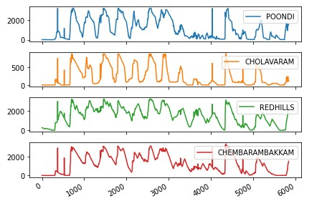

IoT-Based Smart Water Management:

The first device measures the water tank’s height and sends real-time information to the cloud using a smart-level device. The GSM module of the smart level sends a signal to another device, a motor-controlled device, which automatically activates and deactivates the motor based on the signal. They activate and deactivate motors when they receive an input signal.

𝑤𝑡𝑘 𝜌= ⎝∑ , , * ( , ) 𝑖 𝑚𝑁𝐺𝑖 𝑚𝑉𝑡𝑢𝑚𝑖 𝑒 𝑤𝑚𝑖 𝑤𝑡𝑖 ⎞

After activating the mode, the consumer will not utilize the tank throughout the inspection. An application will record an inspection’s beginning and ending times for use in subsequent computations; if no leakage is detected, the inspection will end by itself after 6 h.